Instructions to use the exoskeleton

# Steps for algorithm with vision

1. There are three electronic devices needed.
   * + Project’s laptop >>> to control the exoskeleton
     + Another system with GPU (Nvidia GeForce GTX recommended) >>> for running the computer vision code
     + A camera or A mobile phone with camera >>> used for object detection

>>>in case you use a mobile phone, you should install the app “DroidCam” (it works only with Android)

1. Before starting the procedure, check the position of the motor. It should be in the closed situation (the configuration when the human is standing upright). You can bring back to the starting position by turning the motors by hand. (both simultaneously). The distance between the screw and the part is ok in this configuration. (**They shouldn’t touch each other**) it should be the same for both sides.

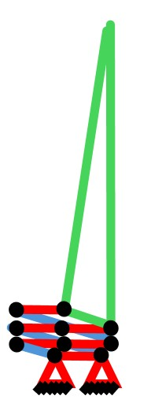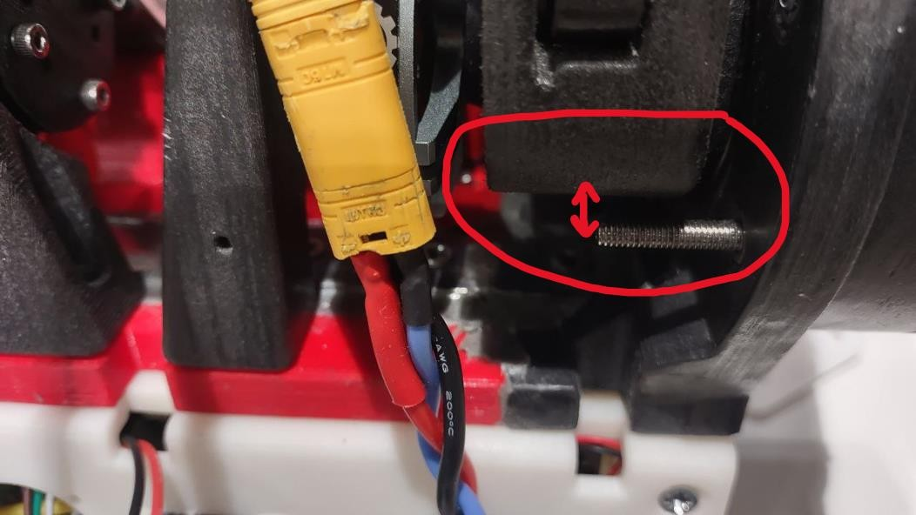

1. Connect the battery >>> check for the turn on sound and check the controller board’s green light inside the white box >>> it is observable from outside no need to open

1. Connect the USB to the laptop of the project

1. Open the tilix command window (terminal) and write the command “odrivetool” and press enter. >>> You should get a message in blue stating the board drive under the name “odrv0”. This indicates the board’s working conditions.

1. 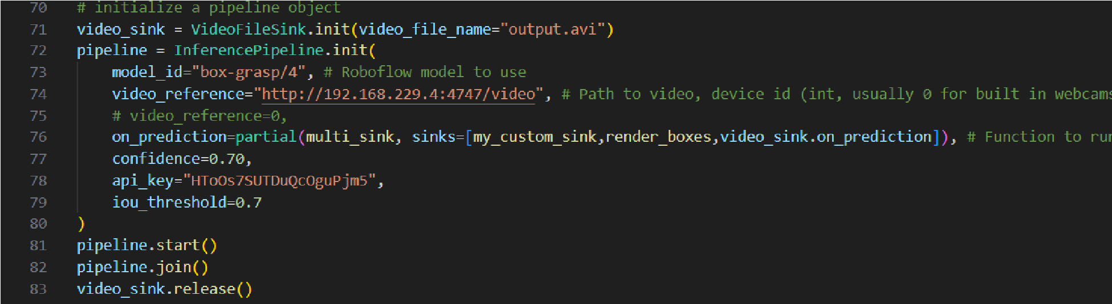To test the connections of the components – Type “dump_errors(odrv0)” >>> We should be presented with “no Errors” in all categories >>> if there were some errors, first unplug the battery, then unplug the USB, the check the connections mentioned in the picture below to be fixed. >>> connect the battery and then the USB again and write “dump_errors(odrv0)” to check the errors.

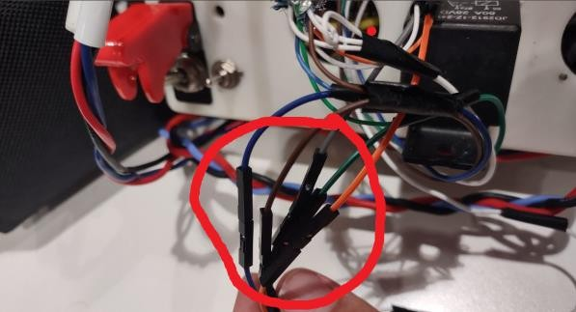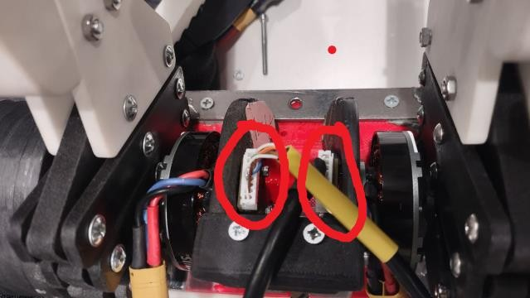

If there are no errors, we can run the codes

1. **Network connection:** Connect the project’s laptop, the system running the vision code, and the mobile phone to the same wi-fi network.
2. **Edit the Computer Vision code:** open the python code “live-detection-pipeline” in the other system by the app vscode (visual studio code). **Don’t run it.**
3. **IP addresses:** 
   * open the app “DroidCam” on the mobile phone find the Device IP and port. Write these data inside the code “live-detection-pipeline” in the line 74 with the following pattern: video_reference = “http:// IP address : port /video”,

For example, in this picture IP address is 192.168.229.4 and the port is 4747. **You just have to edit this code with your data.**

* + In the project’s laptop (the one that runs the control codes) click on Wi-Fi settings and click the gear icon for the Wi-Fi network that is connected to. (this network should be the same as others). Then find the IP address and port. Write these data inside the code “live-detection-pipeline” lines 18 and 19 same as below

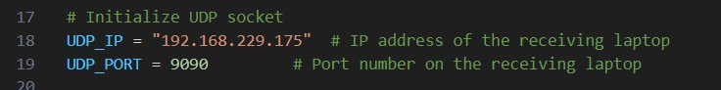

1. **Run the computer vision code:** run the code “live-detection-pipeline” by hitting the play button on the top-right corner.



It takes a couple of minutes running it for the first time. You may get some warnings but wait until it shows the video, or you get some errors.

1. **Reciever code:** in the project’s laptop, open another **tilix** window (using buttons

“**Ctrl+Shift+n”** on an opened tilix window). In the new window, press

**“Ctrl+Shift+b”** to open the bookmarks. Select the 1st one (“**RecieverFolderWithVision**”). Then press again “**Ctrl+Shift+b**” to open the bookmarks. This time select the 4th one (“**run receiver**”) to run the reciever code. This code will get detection data from the other system. You should get a real-time detection status result shown on the command window.

1. **High-level code:** Again, open another **tilix** window (using buttons

“**Ctrl+Shift+n”** on an opened tilix window). In the new window, press

**“Ctrl+Shift+b”** to open the bookmarks. Select the 2nd one (“**HighWithVision**”). Then press again “**Ctrl+Shift+b**” to open the bookmarks. This time select the 5th one (“**Run High**”) to run the high-level code. You should get the message “waiting for ODrive master…”

1. **Low-level code:** Again, open another **tilix** window (using buttons “**Ctrl+Shift+n”** on an opened tilix window). In the new window, press **“Ctrl+Shift+b”** to open the bookmarks. Select the 3rd one (“**ODrive-WithVision**”). Then press again “**Ctrl+Shift+b**” to open the bookmarks. This time select the 6th one (“**Run**

**Master**”) to run the low-level code. >>> you should enter the **password** now

which is “**nearlab123**”. When you are writing the password it doesn’t show the characters but don’t worry it works! Press ENTER after you typed to confirm the password.

>>> the command window will be erased, and another message says press ENTER to continue. **PAY ATTENTION: by pressing “Enter” the device starts working, so, be careful with that.**

* + **You may receive a message that the battery level is below critical value. In that case you must charge it. The procedure is explained later.**

1. by pressing "Enter”, the codes will run, and the device will start working. The data of the sensors are shown on this window (6 numbers in a row) in this sequence:

Position0, Velocity0, Torque0, Position1, Velocity1, Torque1

Data of the torque and velocity should be changing quickly with small numbers due to noise. If the torque values are constant, this means that the motor is stopped. So, you should stop the program using buttons (Ctrl+c) on the window you run the High-level code on step 11 (or pushing the emergency button)

1. You can use the device now. You can move freely. You can grasp a box to feel the assistive force. (pay attention that the camera should look at the box to detect correctly)

1. To stop the program when you finish, use the buttons (Ctrl+c) on the window you run the High-level code on step 11 (or push the emergency button)

# Steps for simple algorithm for free movement

• You only need the project’s laptop to run this code.

1. Before starting the procedure, check the position of the motor. It should be in the closed situation (the configuration when the human is standing upright). You can bring back to the starting position by turning the motors by hand. (both simultaneously). The distance between the screw and the part is ok in this configuration. (**They shouldn’t touch each other**) it should be the same for both sides.



1. Connect the battery >>> check the controller board’s green light inside the white box >>> it is observable from outside no need to open

1. Connect the USB to the laptop of the project

1. Open the tilix command window (terminal) and write the command “odrivetool” and press enter. >>> You should get a message in blue stating the board drive under the name “odrv0”. This indicates the board’s working conditions.

1. To test the connections of the components – Type “dump_errors(odrv0)” >>> We should be presented with “no Errors” in all categories >>> if there were some errors, first unplug the battery, then unplug the USB, the check the connections mentioned in the picture below to be fixed. >>> connect the battery and then the USB again and write “dump_errors(odrv0)” to check the errors.



If there are no errors, we can run the codes

1. **High-level code:** In the project’s laptop, open another **tilix** window (using buttons “**Ctrl+Shift+n”** on an opened tilix window). In the new window, press **“Ctrl+Shift+b”** to open the bookmarks. Select the 7th one (“**High**”). Then press again “**Ctrl+Shift+b**” to open the bookmarks. This time select the 5th one (“**Run**

**High**”) to run the high-level code. You should get the message “waiting for

ODrive master…”

1. **Low-level code:** Again, open another **tilix** window (using buttons “**Ctrl+Shift+n”** on an opened tilix window). In the new window, press **“Ctrl+Shift+b”** to open the bookmarks. Select the 8th one (“**ODrive**”). Then press again “**Ctrl+Shift+b**” to open the bookmarks. This time select the 6th one (“**Run Master**”) to run the lowlevel code. >>> you should enter the **password** now which is “**nearlab123**”. When you are writing the password it doesn’t show the characters but don’t worry it works! Press ENTER after you typed to confirm the password. >>> the command window will be erased, and another message says press ENTER to continue. **PAY ATTENTION: by pressing “Enter” the device starts working, so, be careful with that.**

• **You may receive a message that the battery level is below critical value. In that case you must charge it. The procedure is explained later.**

1. by pressing "Enter”, the codes will run and the device will start working. The data of the sensors are shown on this window (6 numbers in a row) in this sequence:

Position0, Velocity0, Torque0, Position1, Velocity1, Torque1

Data of the torque and velocity should be changing quickly with small numbers due to noise. If the torque values are constant, this means that the motor is stopped. So, you should stop the program using buttons (Ctrl+c) on the window you run the High-level code on step 11 (or pushing the emergency button)

1. You can use the device now. You can move freely. This code has no assistance mode. (You may see “assistance mode” in the command window but neglect it. I forgot to change it.)

1. To stop the program when you finish, use the buttons (Ctrl+c) on the window you run the High-level code on step 11 (or push the emergency button)

# Steps for charging the battery

1. Connect the charger to the wall power (A in the picture below)
2. Connect the red and black cable to the charger (B in the picture)
3. Connect the battery to the cable with “XT90” connection (C in the picture)
4. Connect the white socket to the charger (D in the picture)
5. Put the charger and the battery in a smooth normal-temperature surface.

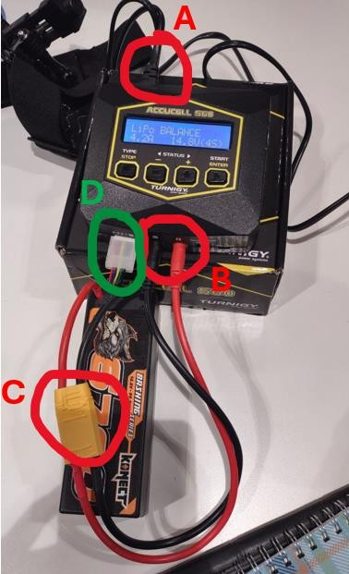

1. Check the screen. It should be written “LiPo BALANCE” with “4.2A” and “14.8V(4S)” on it.

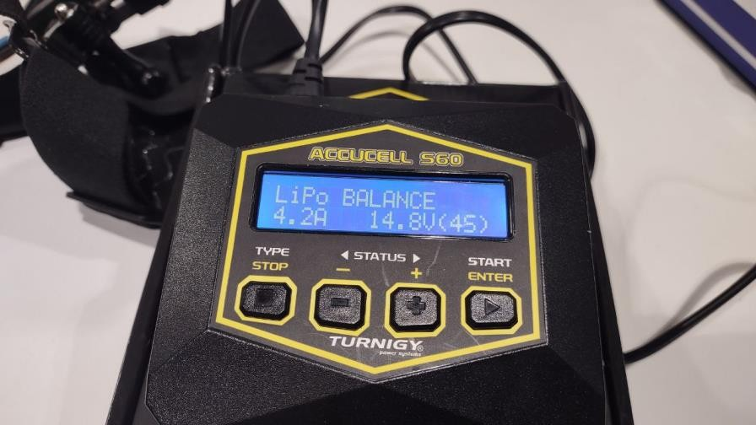

1. Press and hold the “ENTER” button to get the screen below.

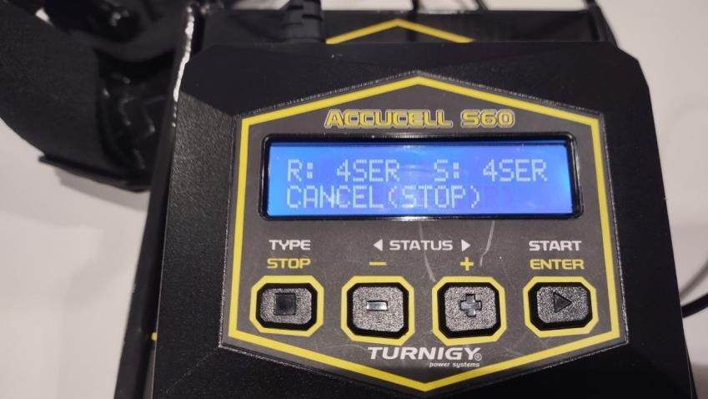

1. Press “ENTER” to continue. If you stay too long in this step without pressing “ENTER” it will turn back to the previous step.
2. The charging started. You can press the button “+” several times until you get the screen below to check for the percentage of the battery. (picture below)

• **DO NOT leave the battery and charger unattended and unsupervised**

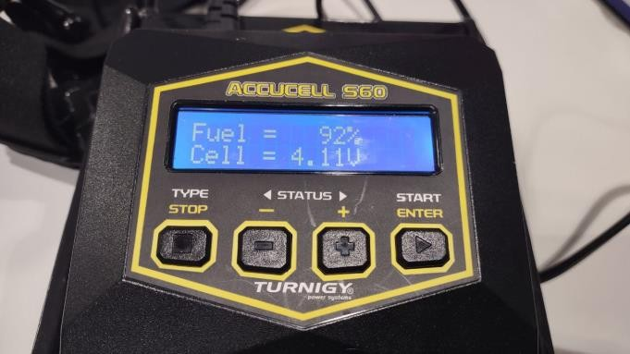

1. Wait until around 96% and then press the button “STOP”
2. Unplug the white socket (D in the picture)
3. Unplug the battery to the cable with “XT90” connection (C in the picture)
4. Unplug the red and black cable to the charger (B in the picture) 14. Unplug the charger to the wall power (A in the picture below)

